Demo Project Proposal

# Statement of Purpose

* Title: Situational Appraisal App
* Purpose: Collect, organize various problems into ranking, and follow on problem solving steps.

# Runtime Environment

* Desktop or Mobile

# Information Needed

* Situation
  + Timing
    - Enum (H, M, L)
  + Trend
    - Enum (H, M, L)
  + Impact
    - Enum (H, M, L)
  + Follow on step
    - Problem analysis
      * What
        + Is
        + Is not
        + Distinction
        + Probable Cause
      * Where
        + Is
        + Is not
        + Distinction
        + Probable Cause
      * When
        + Is
        + Is not
        + Distinction
        + Probable Cause
      * Extent
        + Is
        + Is not
        + Distinction
        + Probable Cause
    - Decision analysis
      * Alternate Solutions
      * Must
      * Wants
      * Want Weights
      * Want Rating
      * Wants Score
      * Solution Total
    - Potential Problem Analysis
      * Probable Cause
      * Preventative Action
      * Contingency Plan

# Data to be Persisted (Data Base)

List what data would saved to a DB in the production application

* + Write sessions to JSON files locally

# App Concerns

* GUI
* Subjective nature of the process and UI

# User Interface Outline and Functional Flow

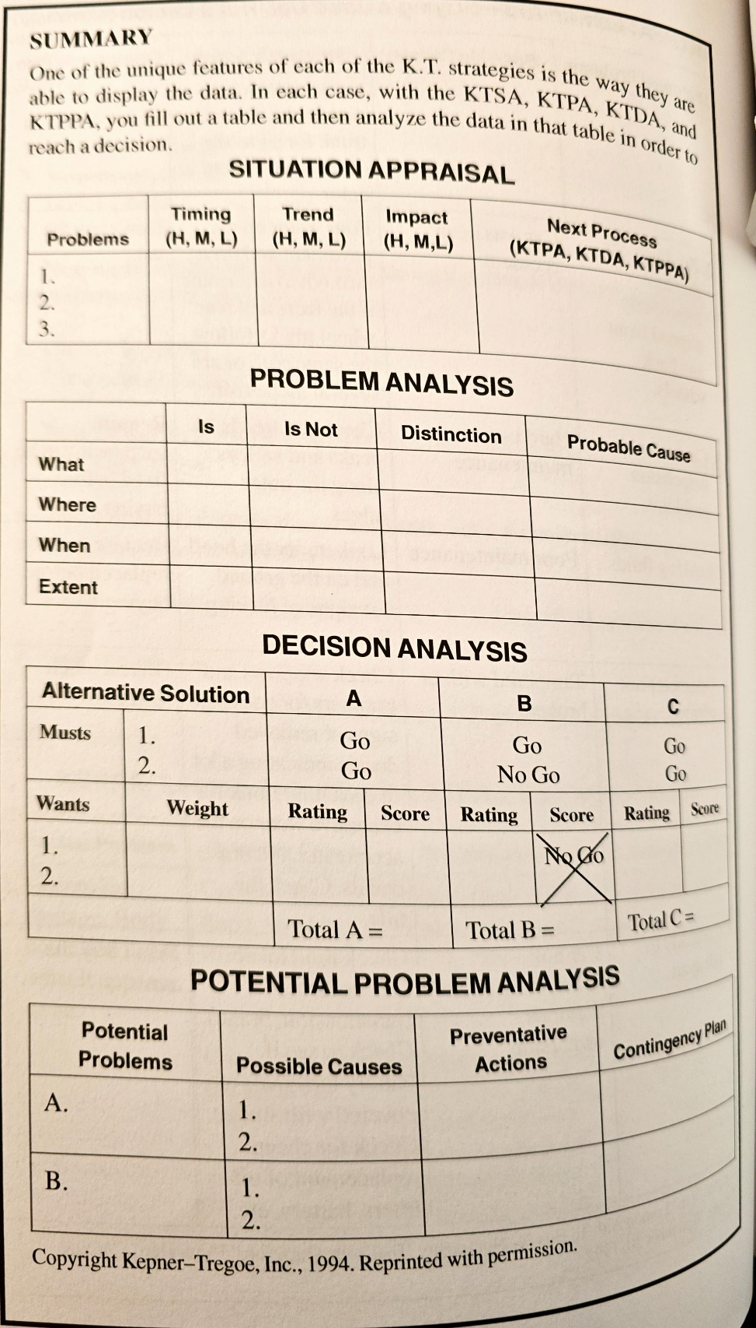Can be an outline in writing, PowerPoint slides (one slide per screen)

# Special Features